Name-Ayan Sadhukhan

Registration Number-19BEC1448

*Question 1:*

**Given ' n' integers, create two lists : one  list with the first n/2 integers if n is even (or with the first (n/2+1) integers when n is odd) and the other list with the remaining elements.**

Sort both the lists in an ascending order separately and name the first list as A and the second sorted list as B.

Merge both the lists A and B, and create a new list called C such that all the elements of A & B are in C and the elements are in an ascending order.

*Code:*

#include<iostream>

#include<algorithm>

using namespace std;

int main()

{

int a[10],b[10];

int n,m;

cout<<"Enter the length of the first list "<<endl;

cin>>n;

cout<<"enter the length of the second list"<<endl;

cin>>m;

cout<<"Enter the first list"<<endl;

for(int i=0;i<n;i++)

{

cout<<"Enter teh element :";

cin>>a[i];

}

cout<<"Enter the second list "<<endl;

for(int i=0;i<m;i++)

{

cout<<"Enter the element :";

cin>>b[i];

}

sort(a,a+n);

sort(b,b+m);

cout<<"The sorted first array is "<<endl;

for(int i=0;i<n;i++)

cout<<a[i]<<" ";

cout<<"The sorted second array is "<<endl;

for(int i=0;i<n;i++)

cout<<b[i]<<" ";

int c[m+n],k=0,i=0,j=0;

while(i<=n && j<=m)

{

if (a[i]<a[j])

{

c[k]=a[i];

k=k+1;

i=i+1;}

else

{c[k]=b[j];

k=k+1;

j=j+1;

}

}

cout<<"The merged array is "<<endl;

for(i=0;i<(n+m);i++)

cout<<c[i]<<" ";

}

*Output:*

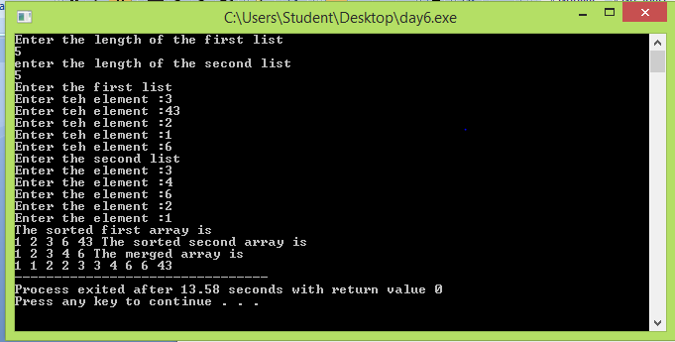

*Question 2:*

**Given ' n' integers, create two lists : one  list with the first n/2 integers if n is even (or with the first (n/2+1) integers when n is odd) and the other list with the remaining elements.**

Given n numbers and another number, k, write an algorithm and the subsequent code to output whether k is present in the list A or B, the position of k in A (or B) and the position of k in C. If k is not present in any of the lists A or B, your code should output -1.

*Code:*

#include<iostream>

#include<algorithm>

using namespace std;

int main()

{

int a[10],b[10];

int n,m;

cout<<"Enter the length of the first list "<<endl;

cin>>n;

cout<<"enter the length of the second list"<<endl;

cin>>m;

cout<<"Enter the first list"<<endl;

for(int i=0;i<n;i++)

{

cout<<"Enter the element :";

cin>>a[i];

}

cout<<"Enter the second list "<<endl;

for(int i=0;i<m;i++)

{

cout<<"Enter the element :";

cin>>b[i];

}

cout<<"The unsorted first array is "<<endl;

for(int i=0;i<n;i++)

cout<<a[i]<<" ";

cout<<endl;

cout<<"The unsorted second array is "<<endl;

for(int i=0;i<n;i++)

cout<<b[i]<<" ";

cout<<endl;

sort(a,a+n);

sort(b,b+m);

cout<<"The sorted first array is "<<endl;

for(int i=0;i<n;i++)

cout<<a[i]<<" ";

cout<<endl;

cout<<"The sorted second array is "<<endl;

for(int i=0;i<n;i++)

cout<<b[i]<<" ";

cout<<endl;

int c[m+n],k=0,i=0,j=0;

while(i<=n && j<=m)

{

if (a[i]<a[j])

{

c[k]=a[i];

k=k+1;

i=i+1;}

else

{c[k]=b[j];

k=k+1;

j=j+1;

}

}

cout<<"The merged array is "<<endl;

for(i=0;i<(n+m);i++)

cout<<c[i]<<" ";

k=0;

cout<<"Enter the element k to be found in the array"<<endl;

cin>>k;

i=0;j=0;

int flag=0;

while(i<=n)

{

if (k==a[i])

{

cout<<"Element present in array A"<<endl;

cout<<"The position of the element in array is "<<(i+1)<<endl;

flag=1;

break;

}

else

{

i=i+1;

}

}

if (flag==0)

cout<<"The element is not present in array A "<<endl;

flag=0;

while(j<=m)

{

if (k==b[j])

{

cout<<"Element present in array B"<<endl;

cout<<"The position of the element in array is "<<(j+1)<<endl;

flag=1;

break;

}

else

{

j=j+1;

}

}

if (flag==0)

cout<<"The element is not present in array B "<<endl;

flag=0;

int f=0;

while(f<=(n+m))

{

if (k==c[f])

{

cout<<"Element present in array C"<<endl;

cout<<"The position of the element in array is "<<(f+1)<<endl;

flag=1;

break;

}

else

{

f=f+1;

}

}

if (flag==0)

cout<<"The element is not present in array C "<<endl;

flag=0;

}

*Output:*

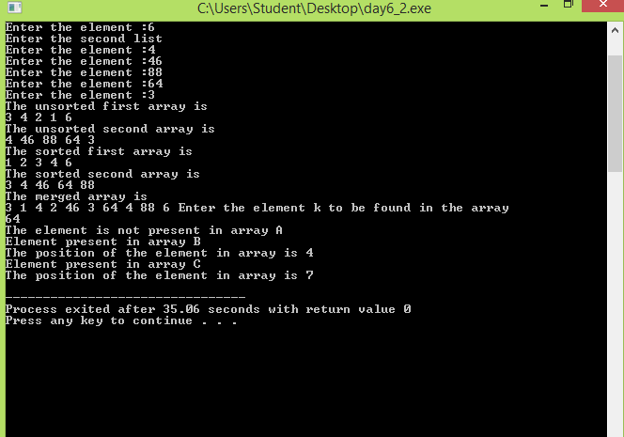

*Question 3:*

Binary Search

*Code:*

#include<iostream>

using namespace std;

int binarySearch(int arr[], int p, int r, int num) {

if (p <= r) {

int mid = (p + r)/2;

if (arr[mid] == num)

return mid ;

if (arr[mid] > num)

return binarySearch(arr, p, mid-1, num);

if (arr[mid] > num)

return binarySearch(arr, mid+1, r, num);

}

return -1;

}

int main(void) {

int arr[] = {1, 3, 7, 15, 18, 20, 25, 33, 36, 40};

int n = sizeof(arr)/ sizeof(arr[0]);

int num = 33;

int index = binarySearch (arr, 0, n-1, num);

if(index == -1)

cout<< num <<" is not present in the array";

else

cout<< num <<" is present at index "<< index <<" in the array";

return 0;

}

*Output:*

